SAS Week 04 Practice Problems / HW 04 prep
This week, we will work together to clean some data on the 2025 Phillies roster. This data will be used on HW 04.
Currently, the data exists in 1 excel spreadsheet, with 4 different sheets for 4 positions (pitchers, catchers, outfielders, infielders).
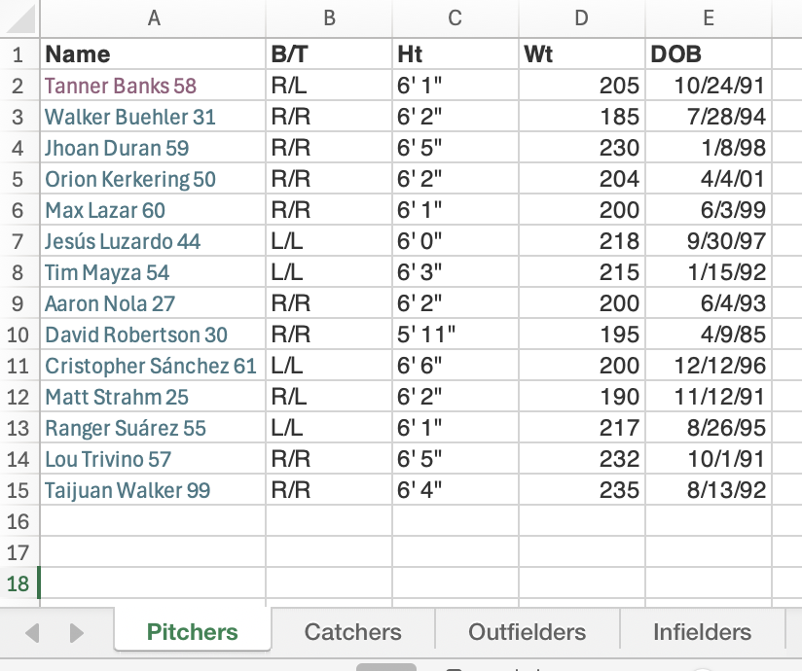
This is real (messy) data I scraped from the internet this week. List out all the cleaning steps you’d need to take to get this in a workable format (don’t worry about syntax/exact coding logic for now).

